Aqsa Iqbal

233063

Web-backend lab

Lab-task-03

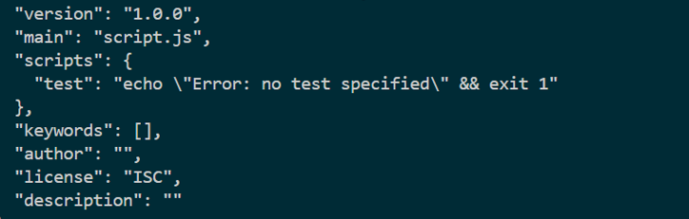

**npm install express mongoose dotenv:**

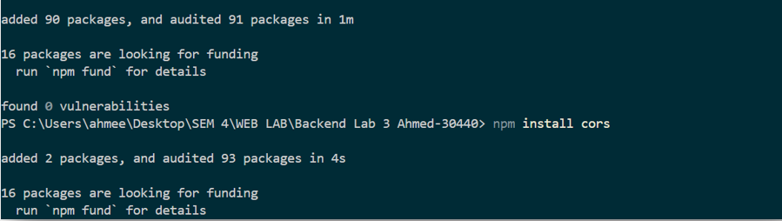

**Server.js**

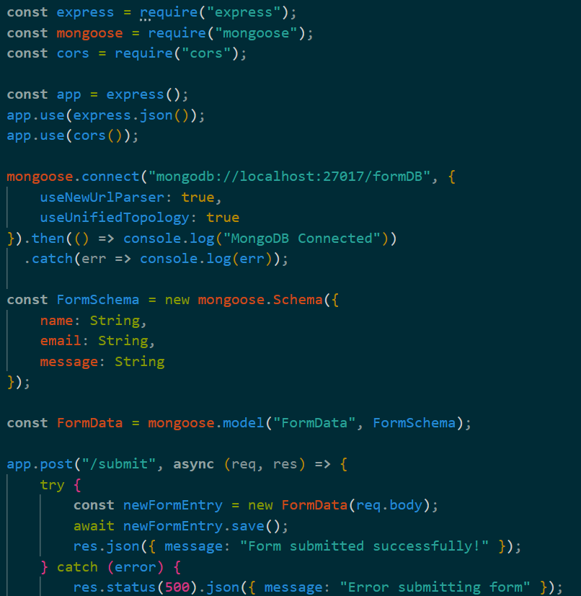

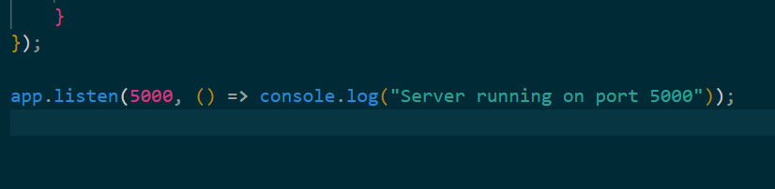

**Index.html:**

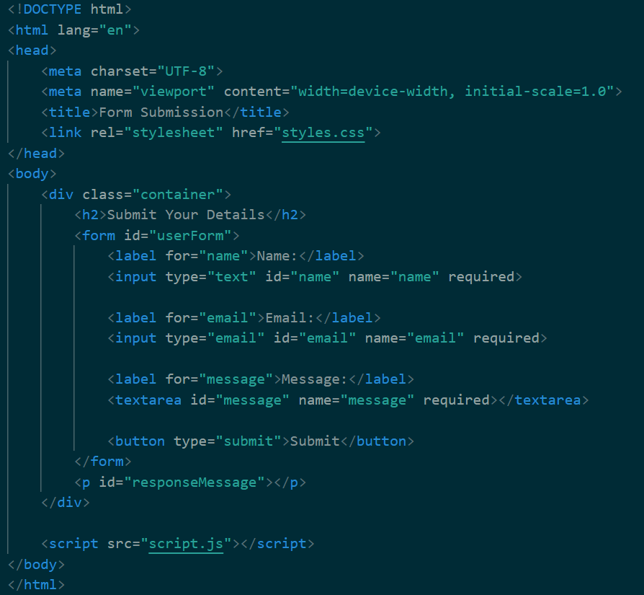

**Mongodb:**

